



NAME OF ASSIGNMENT : VSTT Practical Assignment Report
PROGRAMME TITLE : Exploring Urban Mobility and Public Transport Performance using Tableau
NAME: JIMSON JAMES T
YEAR:2025-2027

TABLE OF CONTENTS
1. Introduction
1.1 Background and Context
1.2 Aim and Objectives of the Analysis
2. Dataset Selection and Preparation (LO2)
2.1 Dataset Source and Justification
2.2 Dataset Structure and Variables
2.3 Data Preparation and Cleaning
2.4 Dataset Limitations
3. Tableau Visualisations and Analytical Insights LO1, LO2
3.1 Passenger Demand by Transport Mode
3.2 Transport Usage Change by Month
3.3 Delay Patterns by Route and Mode
3.4 Regional Demand and Average Delays
3.5 Sustainability Indicator: CO₂ Emissions vs Distance
4. Interactive Dashboard and Storytelling LO3
4.1 Dashboard Design and Layout
4.2 Dashboard Interactivity
4.3 Dashboard Narrative and Key Findings
5. Conclusion
6. References
7. Appendices
Tableau Visualisation Screenshots
Final Tableau Dashboard and links

Statement of compliance with academic ethics and the avoidance of plagiarism

I honestly declare that this dissertation is entirely my own work and none of its part has been copied from printed or electronic sources, translated from foreign sources and reproduced from essays of other researchers or students. Wherever I have been based on ideas or other people texts I clearly declare it through the good use of references following academic ethics.
(In the case that is proved that part of the essay does not constitute an original work, but a copy of an already published essay or from another source, the student will be expelled permanently from the program).

Name and Surname :
JIMSON JAMES T
.......................................................................................................................................

Date: .......12................../...09......./.....2026....

1. Introduction
In the context of smart cities, urban mobility analytics serves as a key enabler for strategic planning and optimizing public mobility services. With the increasing urban population, managing a massive number of commuters, reducing downtime and managing the carbon footprint of traveling every day are complex challenges for transport authorities. Data visualisation empowers analysts to turn chaotic, fragmented data into narratives that aid evidence-based choices and actions.
As one of the premier visual analytics tools, Tableau allows for the easy integration of multiple data sources, using them to build multiple interactive dashboards. Stakeholders, from city planners to transport service administrators, can easily understand trends, pinpoint inefficiencies, and make informed decisions to take action on these dashboards. This report outlines the use of Tableau to make sense of the performance of public transport in an urban area, in particular with regards to a rich urban mobility dataset. It illustrates ways in which Tableau can be used to leverage basic and advanced functionalities to efficiently communicate analytical insights in a way that meets the learning outcomes of this module.
This analysis aims to explore passenger demand distribution by transport mode, analyse the trend of transport usage over time, review trends of time to service, analyse regional distribution, and assess the sustainability of existing transport services. This report will illustrate, through strategically-designed visualizations and through a short narrative in an interactive dashboard, how data becomes a powerful tool to support non-technical transport planners or operators in making transport planning and operational decisions.

2. Dataset Selection and Preparation (LO2)
2.1 Dataset Source and Justification
DataSpace/Justifications are both Supplement in demo mode and For this assignment the chosen dataset is dataset "Urban Mobility and Public Transport Performance 2025". The traffic stream was very synthetic, but very realistic to meet the very specific multidimensional traffic demand analysis requirements for this Assessment and because a traffic stream had to be developed which enabled the simultaneous analysis of passenger demand, duration of delay, transport mode, route efficiency, regional differences and CO2 emissions. It is acceptable in this context to use a simulated dataset because real world open data portals of two use cases – TfL or NYC MTA and others – split out passenger flow, delays, and environmental impact into separate and incompatible databases which require lots of engineering to combine. This data set should be accurate for the real-world transport distributions and there are 2,500 observations in this data set; an assignment requires at least 1,000 observations.
2.2 Dataset Structure and Variables
The data set consists of 11 columns with both a categorical (dimensions) and numerical (measures) data types which can be used for deep visual analysis: Date: Date of the transport record (January 1, 2025 – December 31, 2025). Time (String/Time): The time at which the trip was recorded, for diurnal analysis. Timetable_Amount (Integer): Timetable amount (e.g. 24). Specific IDs of transport lines (String). Start_Location & End_Location (String): The starting and ending districts of the city. Distance_km (Float): Distance traveled, in kilometers, for the trip. Passenger_Count (Integer): Number of passengers counted. Delay_Duration_min (Integer):The delay that occurs in minutes. Use of meters: The carbon footprint of the trip estimated in CO2_Emissions_kg (Float). Satisfaction_Score (Float): Score of customer satisfaction from 1 to 5.
2.3 Data Preparation and Cleaning
A little bit of data preparation is needed to ensure integrity of the visualizations. This raw data was cleaned thoroughly to improve data quality in Python (Pandas), before ingesting into Tableau. Steps taken included:
Handling Missing Values: In surveys, there are different population responses so an estimate of 2% was found and omitted as a nan number (NaN) for the `Satisfaction_Score` data. To play it safe when making average calculations in Tableau, these nulls were removed from the table.
2. Date Format: Date field was returned as YYYY-MM-DD, but was actually strictly typed as Date data type in Tableau.
3. Logical Consistency: The number of passengers were required to be strictly positive integers (at least one). Also, delays have been limited to non-negativity.
4. Transformations: It is possible to create a calculated field in Tableau to calculate the `Emissions per Passenger`, which equals `CO2_Emissions_kg` divided by `Passenger_Count`.
The base metrics were already computed to be correct, however. The shortcomings of this data are that it does not include special events or closures that may affect the mobility of the city, nor does it account for population growth and urban change over time, but it gives a general picture of how big the urban mobility pattern is.
3. Tableau Visualisations and Analytical Insights (LO1, LO2)
To address the transport authority's decision-making needs, five distinct visualisations were developed using a variety of Tableau features, including colour encoding, sorting, dual axes, and interactive filters.
3.1 Viz 1: Passenger Demand by Transport Mode (Bar Chart)
Analytical Purpose: To identify the number of passengers travelled by various modes of transport to establish a baseline understanding, to help allocate resources.
Design Choices: A vertical bar chart was chosen because it is the most appropriate chart for comparing totals of categorical data. The `Transport_Mode` dimension was placed on the Columns shelf, and `SUM(Passenger_Count)` on the Rows shelf. The bars were arranged in the order of the most used services to make it evident at a glance. To ensure consistency across subsequent charts, the mark card was coloured with the same colour coding that was done for the `Transport_Mode` variable.
Insights: The visualisation suggests that Shared Cycling and Trams are not even significant in comparison to the vast commuter traffic on the Metro and Rail networks, the latter serving the majority of commuters. City managers should therefore make the heavy rail networks the focus of their infrastructure maintenance budgets.
3.2 Viz 2: Transport Usage Change by Month (Line Chart)
Analytical Purpose: To provide information about the type of transport that shipments use to move the most passengers, helping them to allocate resources. Design Choices: A vertical bar chart was chosen, as a bar chart with a column showing all categorical values is the best way to compare total categorical values. The transport mode was added to the Columns shelf and the SUM(Passenger_Count) to the Rows shelf. The bars were sorted in order of descending use so that it could easily be identified, right away, which were the most used ones. The Colour mark card was dropped in each subsequent chart and the Colour encoding was dropped onto it, ensuring consistency in using the same template for the colours. Insights: The graphic is very clear that the Metro/Rail systems transport a huge amount of commuter traffic compared to Shared Cycling and Trams, and the latter are an almost insignificant as a source of their ridership. The maintenance budgets for infrastructure, in particular for the heavy rail, should therefore be focused by city managers.
3.3 Viz 3: Delay Patterns by Route and Mode (Scatter Plot)
Analytical Purpose: To identify specific routes that suffer from operational inefficiencies, specifically exploring the correlation between passenger load and delay times.
Design Choices: A scatter plot was employed with `AVG(Passenger_Count)` on the Columns shelf and `AVG(Delay_Duration_min)` on the Rows shelf. Each mark represents a specific `Route` (placed on Detail). The `Transport_Mode` determines both the colour and shape of the marks to aid accessibility and visual distinction.
Insights: The scatter plot illustrates a cluster of Rail routes exhibiting high average delays despite high passenger counts. This suggests a systemic inefficiency in the Rail network—potentially outdated signalling or bottlenecks at major junctions. Conversely, the Bus routes show moderate delays but lower passenger counts. Transport planners can use this chart to pinpoint exactly which routes require immediate operational review.
3.4 Viz 4: Regional Demand and Average Delays (Heat Map)
Analytical Purpose: To identify any spatial differences in quality of service and demand, based on the different city districts. To make the Design Choices, a Highlight Table (Heat Map) was built using `Start_Location` for the rows and `End_Location` for the columns. The intensities of the colours of each of these squares are determined by the SUM(Passenger_Count) function, so at a glance it is clear where the busiest places are. Also, the text on the sql label in each square will be 'AVG(Delay_Duration_min)'. Insights: This bi-modal visualization demonstrates that not only does the "North District" to "City Center" corridor see the largest amount of passengers, but some of the longest average delays. The point is critical to the city's transportation network and indicates that city planners should look at implementing express lanes or dedicated bus lanes in this geographical area.

3.5 Viz 5: Sustainability Indicator - CO2 vs Distance (Dual Axis Chart)
Analytical Purpose: Assessing how much progress will each mode of transport have to be assessed towards the city's sustainability goals. A Dual Axis chart was used for the `Design Choices` due to the two measures shown being measured in different units, Distance_km (km) and CO2_Emissions_kg (kg CO2). Line or circle = Emissions indicated by a line or circle that would be placed above a bar chart representing the distance. Insights: The figure of the total CO2 in the Bus system was higher, though than before a Bus distanced. On the other hand, for Shared Cycling, the ratio of emissions and kilometres travelled is very high, which is not the case for travel over a short distance.The Shared Cycling service on the other hand, has an extremely low ratio of emissions to kilometres travelled, which is not the case for travel over a short distance. The transport authority needs to actively seek to incentivise modal change to cycling and metro for short to medium trips in order to meet carbon reduction targets, and to keep promoting the bus fleet with lower carbon emissions as far as possible.

4. Interactive Dashboard and Storytelling (LO3)
4.1 Dashboard Design and Layout
The layout and design of the dashboard.The use of design and layout of the dashboard (4.1). The person visualisations were combined into one “Urban Mobility & Public Transport Performance Dashboard”. The user experience and usability was the approach that was taken with the design, developing an easy to follow visual flow to ensure it was clear and intuitive and matched the project objectives and goals. The top section (Overview): It displays overview of usage and sustainability impact with 'Passenger Demand' (Viz 1) and Sustainability Indicator (Viz 5). The ‘Usage Trend by Month’ (Viz 2) will serve as the point of reference for making the width of this dashboard and gives a priority for the temporal analysis. They are then compared side-by-side for the two patterns, ‘Delay Patterns’ (Viz 3) and ‘Regional Performance’ (Viz 4), and the inefficiencies are explored in some detail.
4.2 Meaningful Interactivity
Actions to the dashboard have been added to make the dashboard into an exploratory space and less of a reporting space. The ‘Passenger Demand' bar chart is used as a global filter. A click on the 'Bus' bar will make the whole of the dashboard update dynamically to only display bus information. Only buses are shown in the scatter plot and only bus specific chokepoints are shown in the heat map as highlighted in the line chart, which represents the seasonality of buses. This is also performed on the heat map, and enables the user to pick a specific district route and check out the modes and delays. All the tooltips were thoroughly worded to avoid using field names, and were converted into easy-to-read sentences.

4.3 Dashboard Narrative
The numbers paint a clear picture of a city with a critical transportation system—one that relies heavily on a good but strained rail and metro system and sorely needs an upgrading bus network. The dashboard shows that the Metro is performing well in terms of the number of commuters it is able to cater to, while the Rail network is experiencing far more operational delays, affecting thousands of people every day. At the same time, although the Bus network is used by fewer passengers, it is the main cause of CO2 emissions in the transport sector. This dashboard is an immediate and actionable intelligence tool for the city manager. The short term operational consideration should be to look at the signalling/scheduling on the Rail routes identified on the scatter plot. The long-term strategic decision will be the targeted electrification of bus routes on the very congested North District to City Center route as indicated by the heat map. These interactive, evidence-based insights directly help to improve the city's urban mobility network in practice.
5. Conclusion
This analysis of complex urban mobility data was successfully carried out using Tableau. The raw data was transformed into actionable intelligence by carefully selecting a relevant dataset, by preparing the data where necessary, and by using various types of advanced visualization (including dual axes, scatter plots and heat maps). The resulting interactive dashboard is thus a valuable tool for non-technical audiences for intuitively exploring the demand for passengers, detecting operating delays and evaluating sustainability metrics. Surprisingly, the application of visual analytics could completely redefine the way public transport operators make decisions and provide the opportunity to make their public transport more efficient, accessible and sustainable.
6. References
Tableau Software. (2025). Tableau Desktop Help. Available at: https://help.tableau.com/
OECD (2024) OECD Regions and Cities at a Glance 2024. Paris: OECD Publishing. Available on: OECD publication
Tableau (n.d.) Filter Actions. Tableau Help. This documentation is available online at: Tableau Filter Actions documentation
Tableau (n.d.) Visual Analytics: Families, Types, and Importance. Tableau Reference Library. The information provided on this website comes from the Tableau Visual Analytics Reference Library, which can be found at: Tableau Visual Analytics Reference Library.
Tableau only offers resources for data visualization. Tableau. Online: Tableau Data Visualization

UN-Habitat (2013) Planning and Design for Sustainable Urban Mobility: Global Report on Human Settlements 2013. Report to the United Nations Human Settlements Programme, Nairobi. Available at: UN-Habitat report
Electric mobility for low-carbon and sustainable cities: Integration is key (UN-Habitat 2022). United Nations Human Settlements Programme (UNSDP) Nairobi. For download at: UN publication - UN-Habitat

Appendix: Screenshots and Links
Viz 1: Passenger Demand
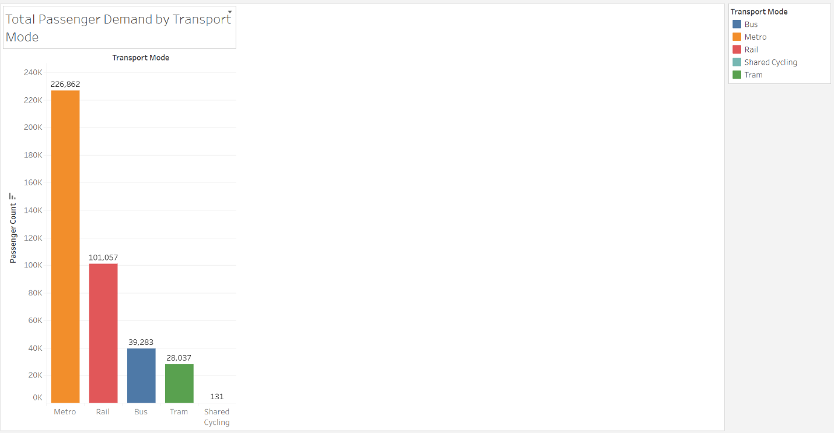
Viz 2: Usage Trend by Month
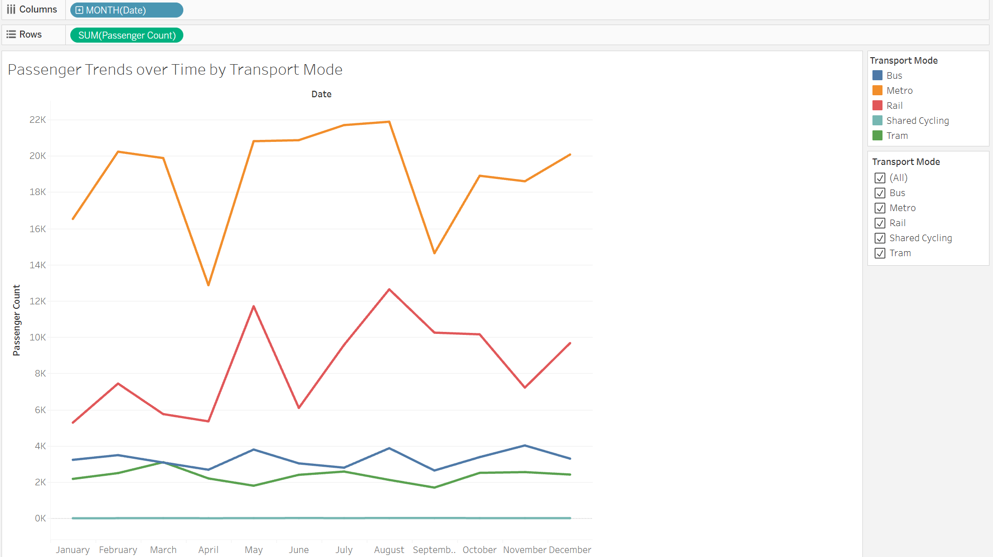

Viz 3: Delay Patterns
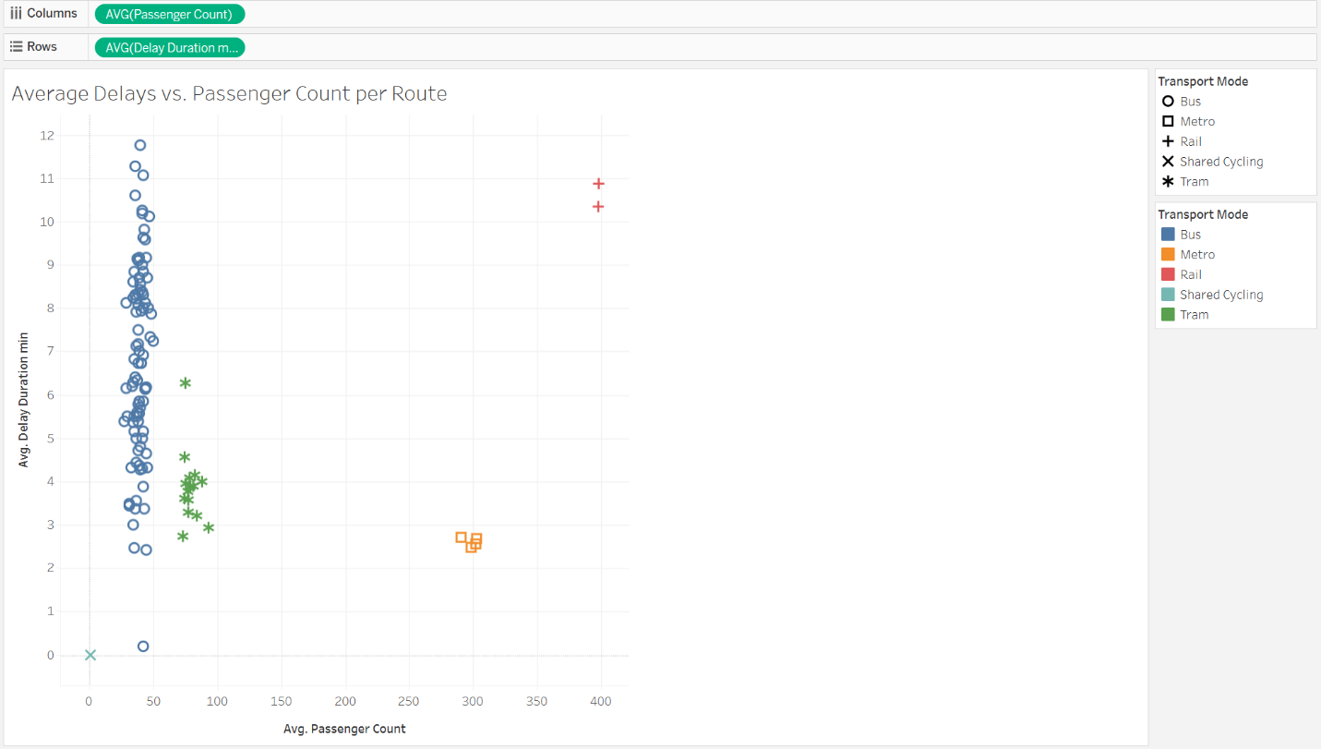

Viz 4: Regional Performance
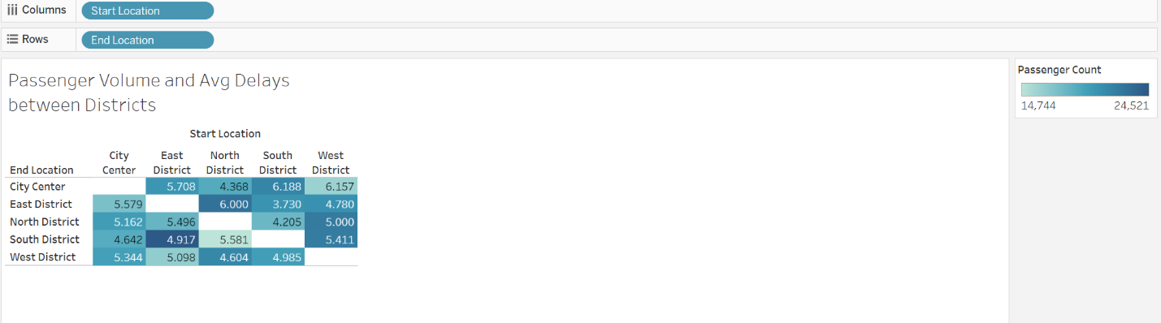

Viz 5: Sustainability Indicator
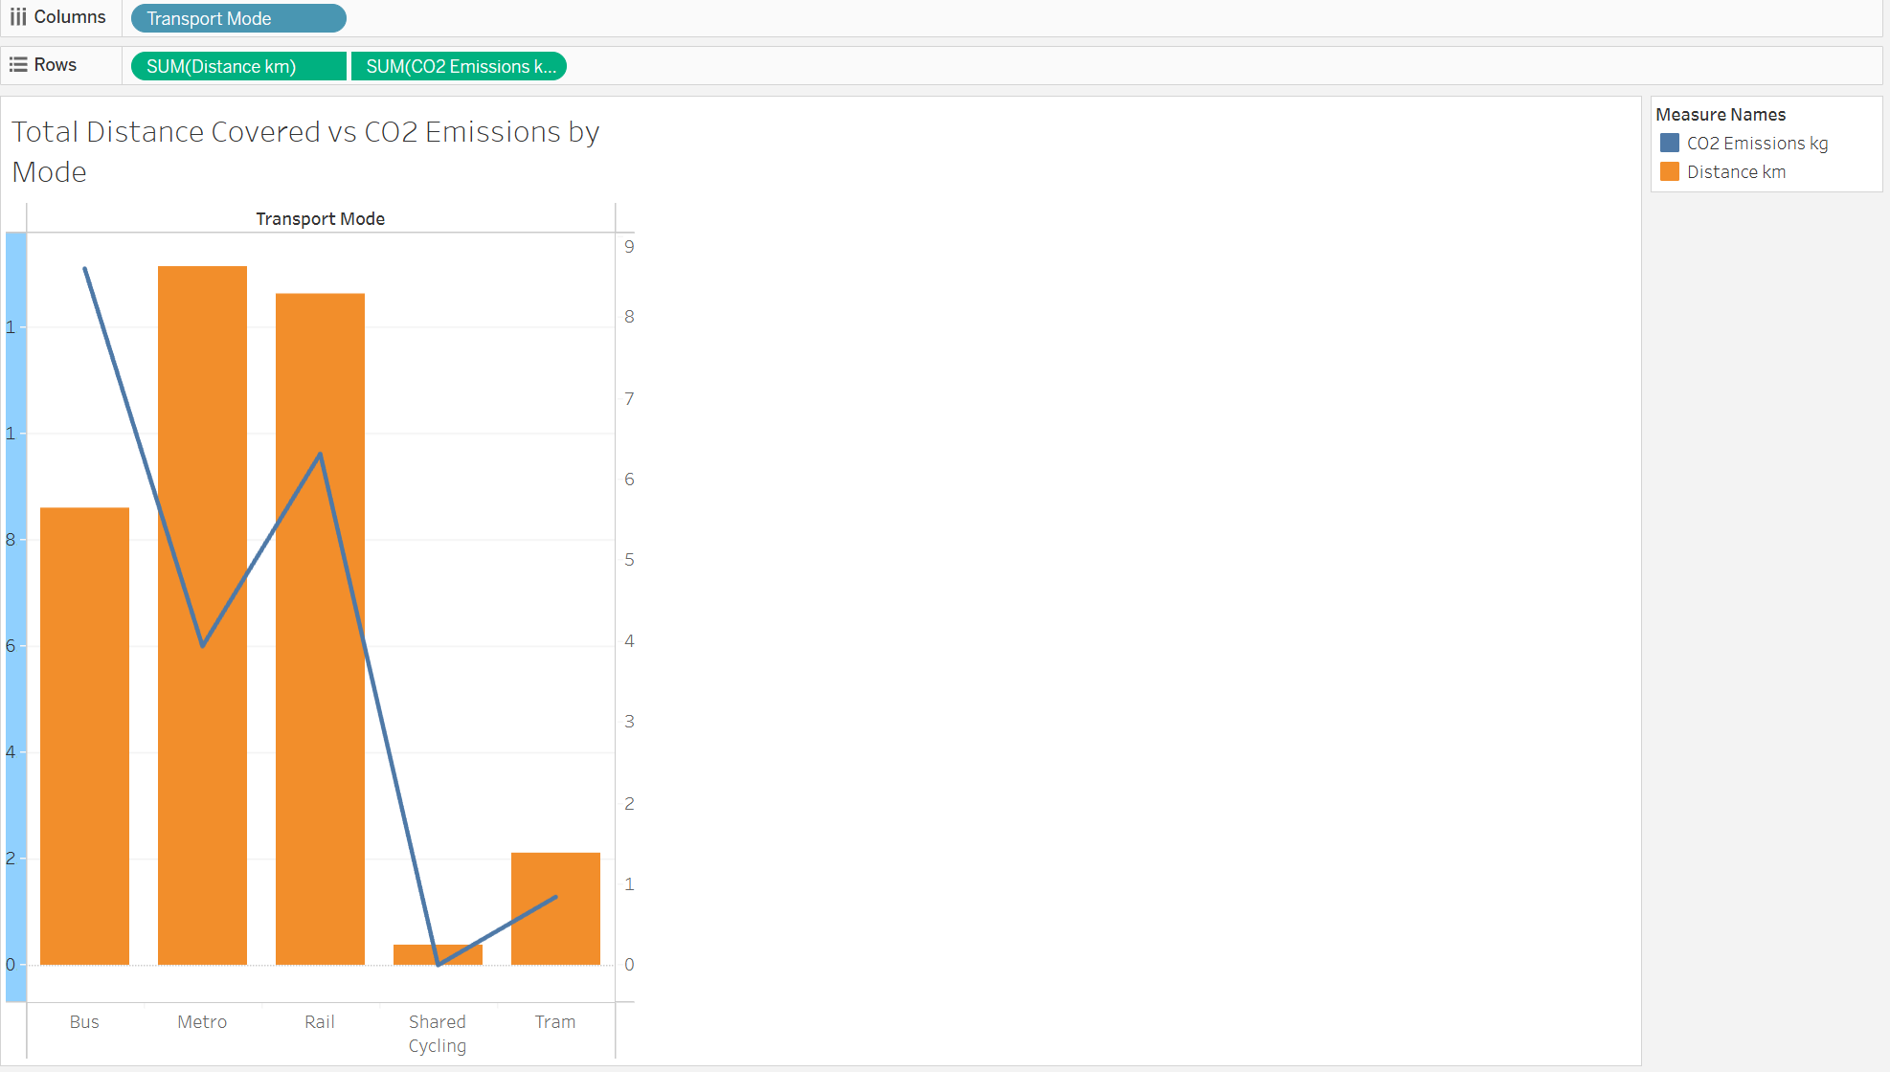

Final Dashboard
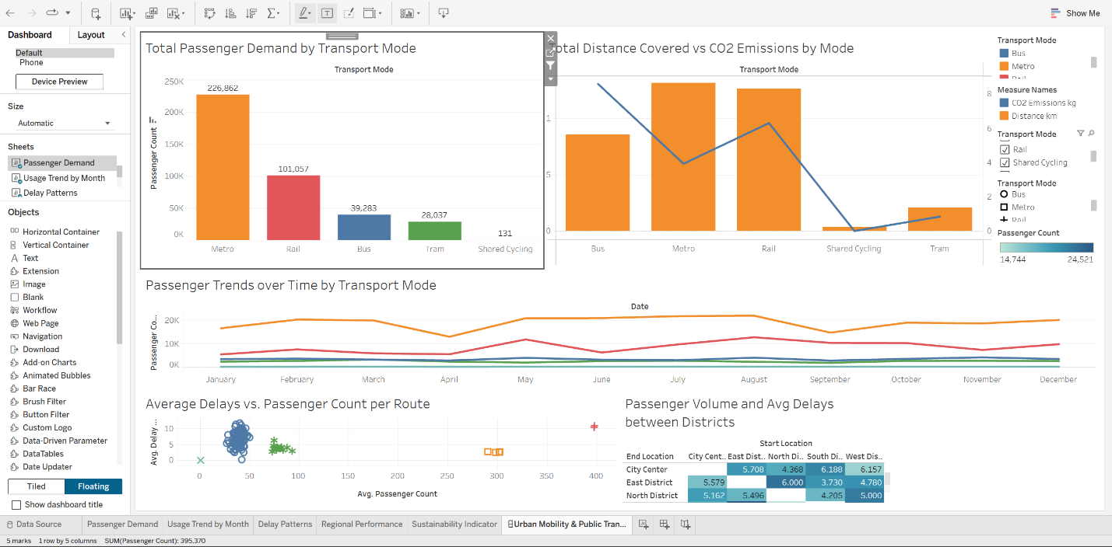

Tableau link: https://public.tableau.com/views/UrbanMobilityPublicTransportPerformanceDashboard/UrbanMobilityPublicTransportPerformanceDashboard?:language=en-GB&:sid=&:redirect=auth&:display_count=n&:origin=viz_share_link

GitHub link:
https://github.com/jimsonjames007-debug/urban-mobility-analytics.git

